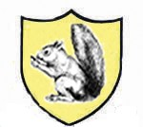
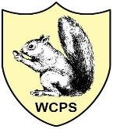
WCPS Uniform

Year 1 & 2
Available from The King’s College School Shop
The Lodge, Woodhayes Road, Wimbledon, SW19 4RJ
Tel: 020 8255 5405
Email:schoolshop@kcs.org.uk

Years 1 and 2:
WCPS Coat – Waterproof with badge
WCPS Grey Beanie Hat | To be worn in the winter months during  playtimes and sports lessons
WCPS Grey Baseball cap | To be worn in the summer months during  playtimes and sports lessons
School Scarf (optional)
Astro Trainers – black-velcro fastening only
Water Bottle | Named
Name Tapes
WCPS Backpack
Day Uniform:
WCPS Grey Blazer with Badge
Standard Grey Shorts or Trousers
Grey Pullover with School Colours
Tie
Grey Socks with School Colours (short or long)
Black Leather Shoes
Painting Overall – Any type
Grey Shirt (Long Sleeved) –Winter
Grey Shirt (Short Sleeved) – Summer
PE Uniform:
WCPS badged Zipped fleece
WCPS badged Polo T-Shirt
WCPS badged Joggers
WCPS badged Shorts
Grey School Socks Short
WCPS Yellow Football Shirt
Football Socks in School Colours
Football Boots (football and rugby use) – any colour | Year 1 and 2 only
All garments and equipment, including shoes, MUST be clearly marked with the pupils name.

